SKILLFORGE
System Architecture, Orchestration & UI/UX Flow Specification
Companion document to the Detailed Functional PRD — for Antigravity / engineering implementation
Includes: layered architecture, service orchestration & sequence flows, event model, sample low-fidelity UI wireframes, end-to-end functional flow diagrams, and a full site map.

1. Purpose of This Document
This document complements the Detailed Functional PRD by answering three questions visually and concretely: how the system is structured (Architecture), how its parts coordinate to actually get work done (Orchestration), and what the product looks and feels like screen by screen (Sample UI Design & Flow of Functionalities). It is written to be handed to an AI-assisted engineering tool (e.g. Antigravity) or a human engineering team alongside the PRD as the shared mental model for how to build the system, not just what to build.

2. System Architecture Overview
SkillForge is organized as a modular, service-oriented monolith-to-microservices-ready architecture: logically separated service modules behind a single API gateway, sharing a relational database initially, with clear seams for later extraction into independent services as scale requires. The AI layer and background-job layer are deliberately isolated so models, prompts and providers can evolve without destabilizing the core product.
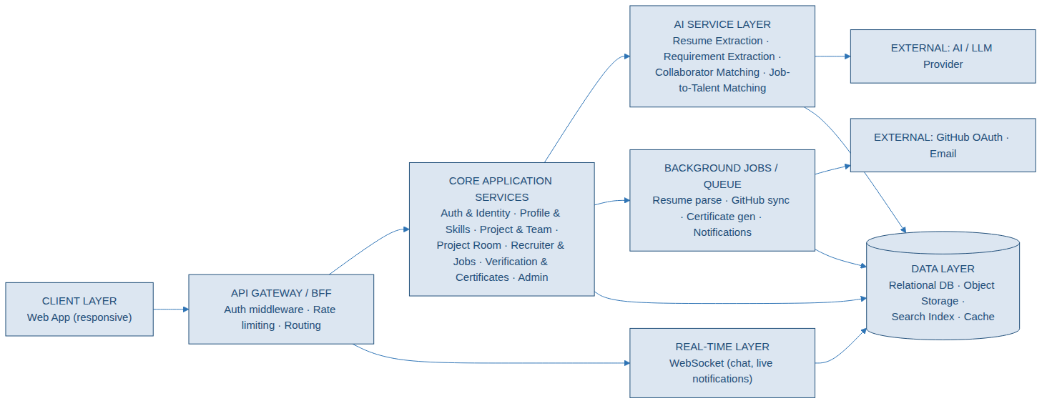
Figure 2.1 — Layered system architecture: client, gateway, core services, AI layer, background jobs, real-time layer, data layer and external integrations.

2.1 Layer Responsibilities
Layer | Responsibility | Notes
Client Layer | Responsive web application; all core surfaces (profile, discovery, Project Room, recruiter dashboard, admin console). | Mobile web first-class, not an afterthought.
API Gateway / BFF | Central entry point: authentication middleware, rate limiting, request routing to service modules. | Single place to enforce cross-cutting security policy.
Core Application Services | Auth & Identity, Profile & Skills, Project & Team, Project Room, Recruiter & Jobs, Verification & Certificates, Admin. | Each owns its own tables/schema slice; communicates via internal APIs/events, not direct DB reads across modules.
AI Service Layer | Resume extraction, project-requirement extraction, collaborator matching, job-to-talent matching. | Isolated module boundary so models/providers can change independently.
Background Jobs / Queue | Resume parsing, GitHub sync, certificate generation, notification delivery — all asynchronous. | Never block a user-facing request on slow external calls.
Real-Time Layer | WebSocket service powering group/individual chat and live in-app notifications. | Scales per-project/per-connection, not a single global socket.
Data Layer | Relational database (core entities), object storage (resumes/files/certificates), search index, cache. | Indexed for skill/location/project-stage query patterns.
External Integrations | GitHub OAuth API, email provider, AI/LLM provider. | Accessed only from the AI layer and background workers, never directly from the client.

2.2 Suggested Technology Stack
Concern | Suggested Approach
Frontend | Component-based SPA framework (e.g. React/Next.js), responsive layout, role-specific dashboards for individuals and recruiters.
API layer | REST or GraphQL, organized by the module boundaries in section 2.1, with a shared auth middleware.
Database | Relational database (e.g. PostgreSQL) for all core entities in the PRD's data model, with proper foreign keys and indexes.
Object storage | Access-controlled bucket storage (e.g. S3-compatible) for resumes, uploaded files, certificate PDFs — signed URLs only, never public paths.
Queue / background jobs | Managed message queue (e.g. SQS/RabbitMQ/Redis-backed queue) with worker processes for async pipelines.
Real-time | WebSocket service (e.g. Socket.IO or a managed real-time platform) scoped per project room.
AI layer | A dedicated internal service/module wrapping calls to an LLM provider, with prompt templates versioned separately from application code.
Search | Start with database-native full-text/indexed search; introduce a dedicated search engine or vector store only once scale genuinely requires it.
Observability | Centralized logging, error tracking, and an audit-event store from day one (see PRD section 8).
Deployment | Containerized services, separate dev/staging/production environments, CI/CD pipeline.

3. Orchestration & Data Flow
Orchestration describes how the modules above actually coordinate, in sequence, to deliver each meaningful piece of product behavior. The three pipelines below are the most important in the system because they each cross multiple layers (client, service, AI, queue, data) and must degrade gracefully on partial failure.

3.1 Resume Parsing Pipeline
Human-in-the-loop by design: the AI worker never writes directly to a live profile. It produces a reviewable extraction record; only user-confirmed fields are merged.
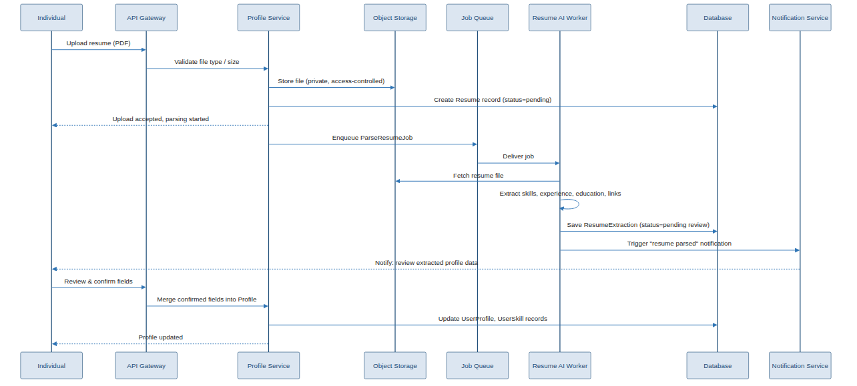
Figure 3.1 — Resume upload → async AI extraction → human review → profile merge.

3.2 AI Collaborator Matching Pipeline
Requirement extraction and collaborator matching are two distinct, chained AI calls: the first turns a plain-language project description into structured requirements; the second turns those requirements plus the candidate pool into a ranked, explainable shortlist. Outcomes (invited/accepted/declined) feed back into the evaluation loop described in the PRD's AI Matching Philosophy section.
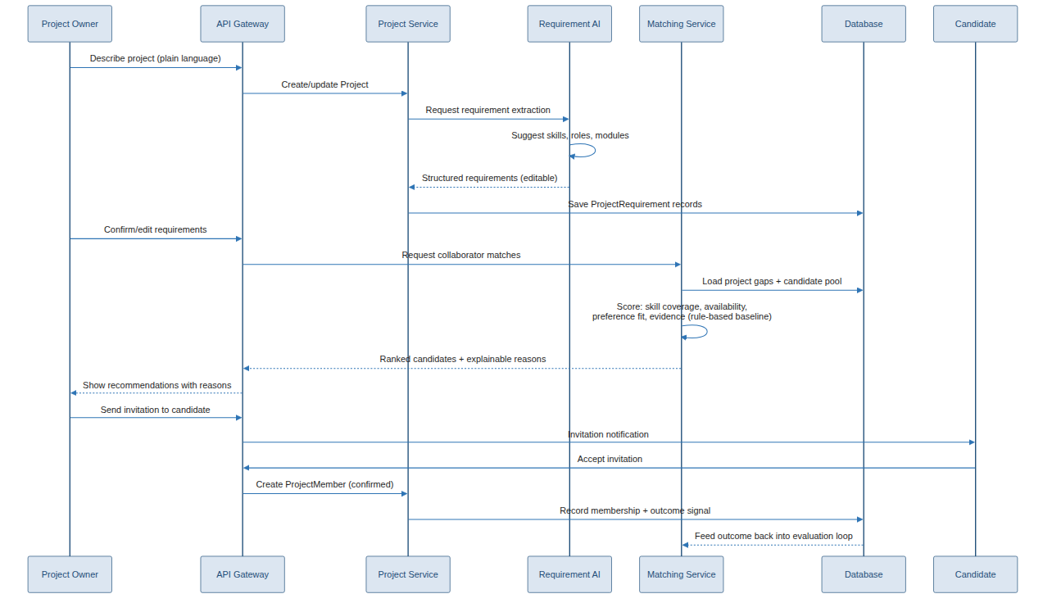
Figure 3.2 — Project requirement extraction, ranked candidate matching, invitation and outcome feedback loop.

3.3 Completion → Verification → Certificate → Portfolio Pipeline
This is the pipeline that turns collaborative work into a career asset. Verification branches into an automatic path (objective rules satisfied) or an admin-review path; either way, an evidence snapshot is frozen before certificates are generated, so later edits to the live project can never silently rewrite someone's certificate or verified-experience record.
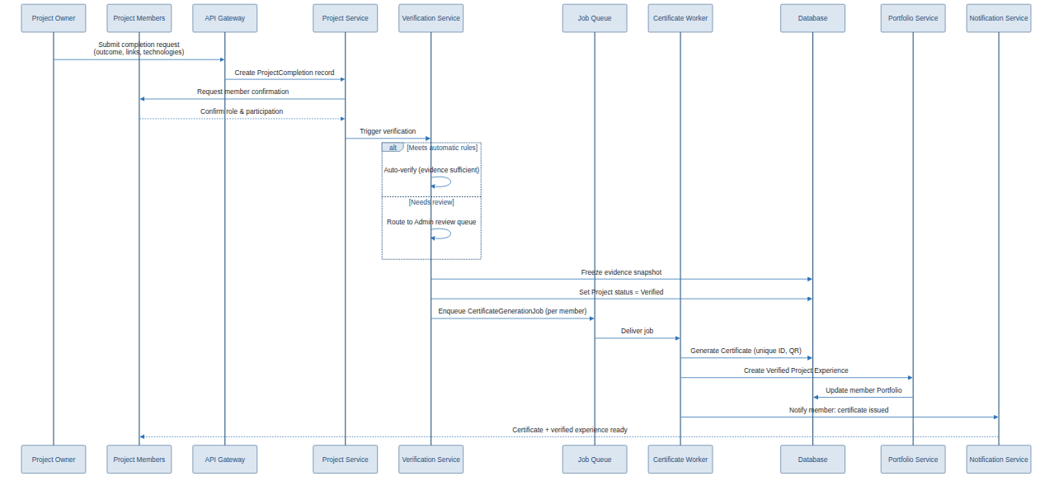
Figure 3.3 — Completion request → member confirmation → verification → evidence snapshot → certificate generation → portfolio update.

3.4 Event-Driven Orchestration & Domain Events
Rather than services calling each other synchronously for every side-effect, key state changes are published as domain events on a shared event bus/queue. Multiple independent consumers react to the same event without the producing service needing to know who's listening — this keeps notification, contribution-evidence, analytics, search-index and audit-log concerns decoupled from core business logic.
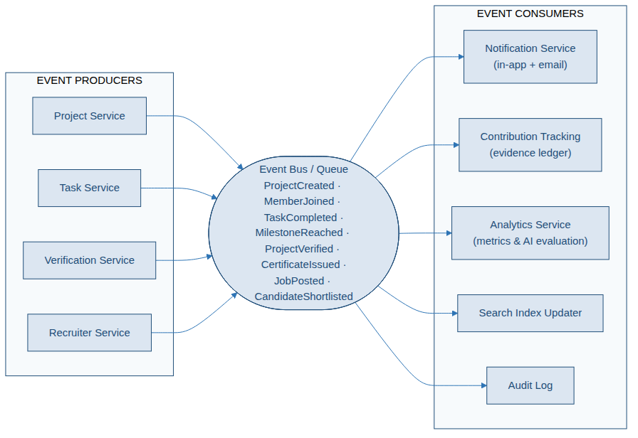
Figure 3.4 — Domain events published by core services and consumed independently by notification, evidence, analytics, search and audit systems.

Key Domain Events
Event | Typically Published By | Typically Consumed By
ProjectCreated / ProjectUpdated | Project Service | Search Index, Analytics
MemberJoined / MemberLeft | Project Service | Notification, Contribution Tracking, Analytics
TaskCompleted | Task Service | Contribution Tracking, Project Health, Notification
MilestoneReached | Task Service | Notification, Project Health, Analytics
ProjectVerified | Verification Service | Certificate Worker, Portfolio Service, Notification, Analytics
CertificateIssued | Certificate Worker | Notification, Portfolio Service, Audit Log
JobPosted / JobClosed | Recruiter Service | Search Index, AI Matching, Notification
CandidateShortlisted / Contacted | Recruiter Service | Notification, Analytics

4. Sample UI Design (Low-Fidelity Wireframes)
These wireframes show layout and information hierarchy, not final visual design — the goal is to communicate what belongs on each core screen and why, so engineering and visual design can both work from the same structural understanding.

4.1 Profile & Onboarding
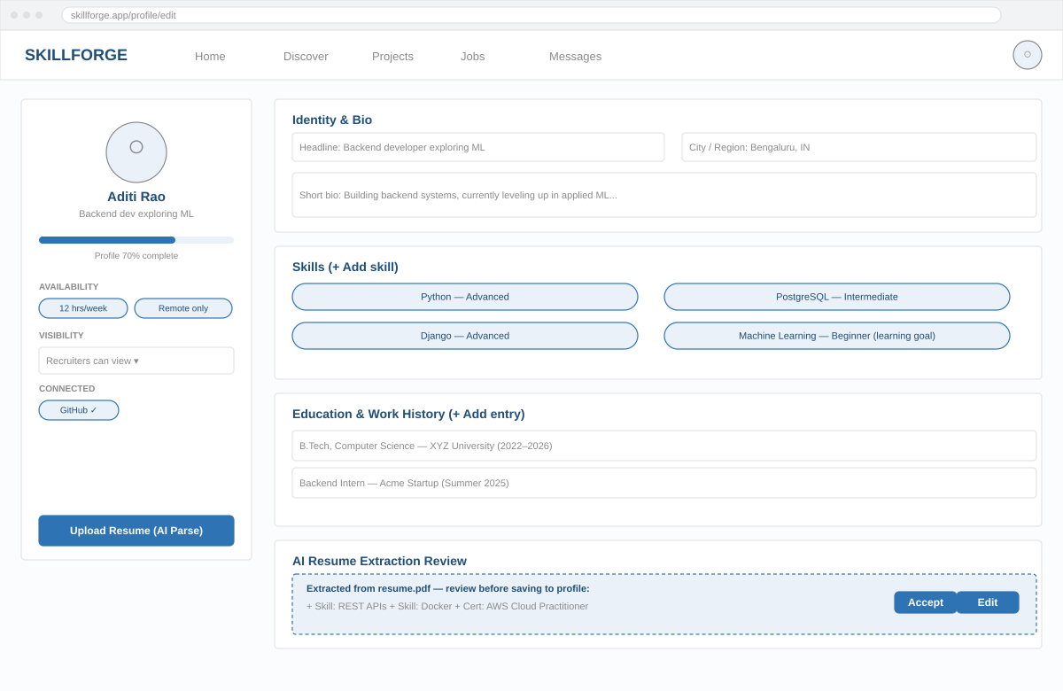
Figure 4.1 — Universal profile editor: identity, skills with evidence-ready structure, education/work history, and the AI resume-extraction review panel (human-in-the-loop).
- Left rail: identity summary, profile-completeness meter, availability/visibility controls, connected integrations, and the resume-upload entry point.
- Main panel: editable sections matching the data model 1:1 (identity, skills, education/work history).
- Bottom panel: AI-extracted resume fields shown as a distinct, dismissible review card — never silently merged.

4.2 Project Discovery & AI Collaborator Matching
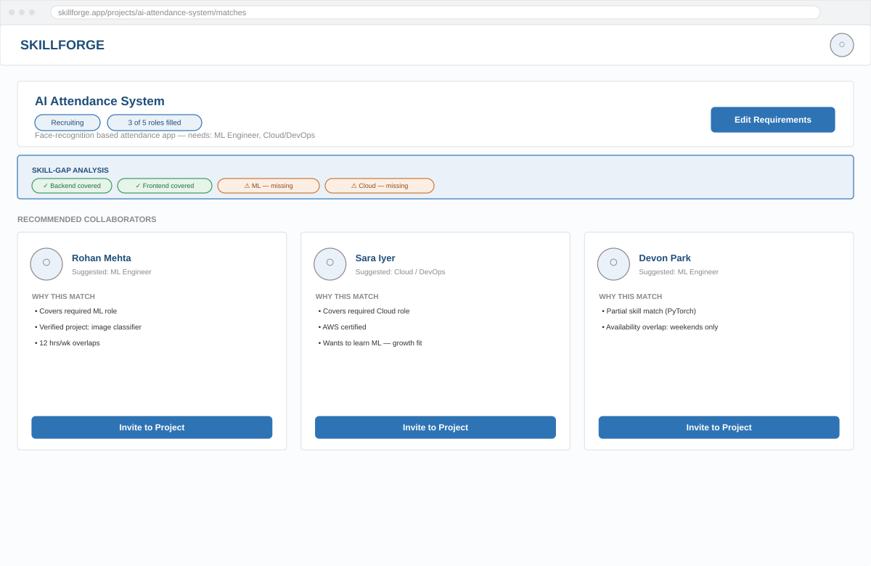
Figure 4.2 — Project header with live skill-gap analysis, and ranked candidate cards each carrying explicit, specific match reasons.
- Gap-analysis strip translates AI requirement extraction into a plain covered/missing status per skill area.
- Every candidate card shows 2–3 concrete reasons instead of a bare score, per the PRD's explainability rule.
- "Invite to Project" is the only write action here — matching never auto-assigns a member.

4.3 Project Room
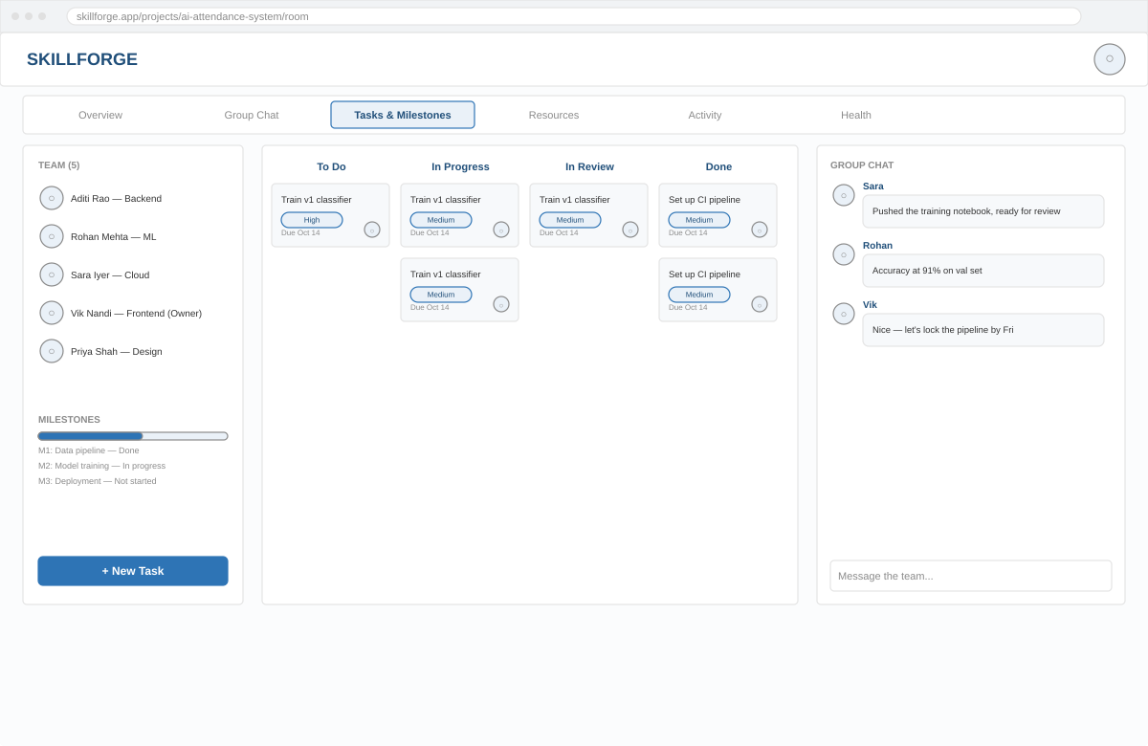
Figure 4.3 — Tabbed Project Room: team roster and milestone progress (left), Kanban task board (center), group chat (right).
- Tab bar mirrors the PRD's Project Room sub-areas: Overview, Group Chat, Tasks & Milestones, Resources, Activity, Health.
- Task cards carry priority, assignee and due date — the exact fields that later become contribution evidence.
- Chat panel is scoped to this project only; individual (1:1) chat is a separate, private surface not shown on the shared board.

4.4 Recruiter Dashboard & Talent Search
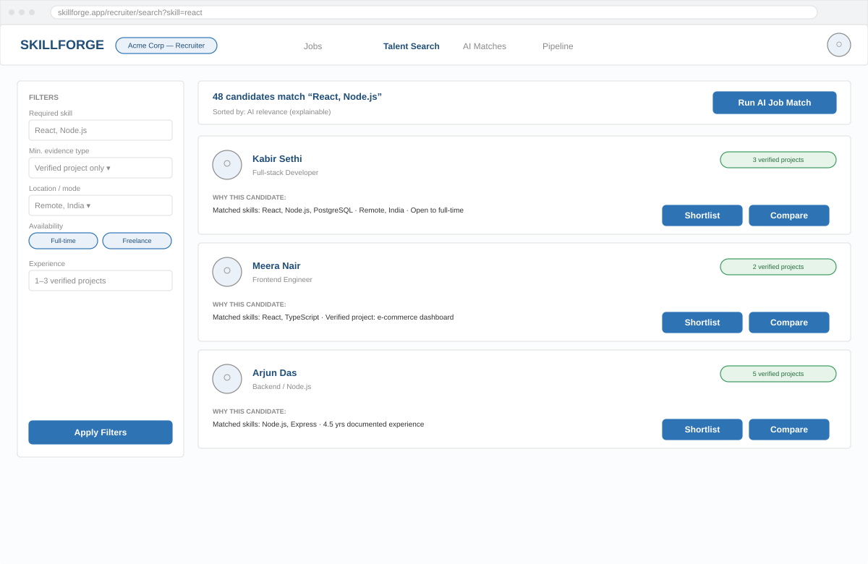
Figure 4.4 — Direct filter-based search (left) alongside explainable AI job-matching results, each candidate showing why they matched.
- Filters are a first-class, always-available path — recruiters are never forced through AI matching alone.
- Verified-project-count badge is shown prominently because verified evidence is weighted above self-declared skills.
- Shortlist and Compare are the two actions that move a candidate into the hiring pipeline (PRD area 25).

4.5 Portfolio & Certificate View
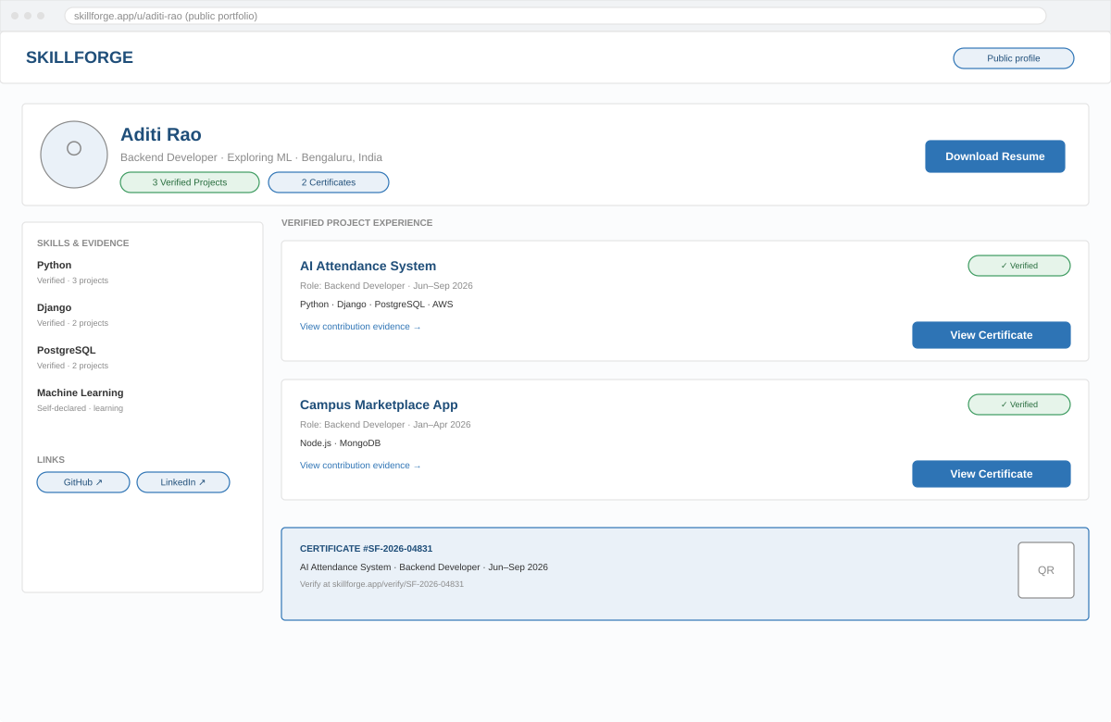
Figure 4.5 — Public portfolio with evidence-linked skills, verified project cards, and an embedded certificate with QR verification.
- Every listed skill shows its evidence type (verified vs. self-declared) rather than a single ambiguous rating.
- Each verified project links out to its underlying contribution evidence, not just a static description.
- The certificate block mirrors exactly what a third party sees on the public verification page.

5. Flow of Functionalities — Visualized User Journeys
Each journey below is shown as a left-to-right sequence, split across rows for readability. These are the same five core journeys from the PRD, now visualized so implementation order and screen transitions are unambiguous.

5.1 Individual → Project Team
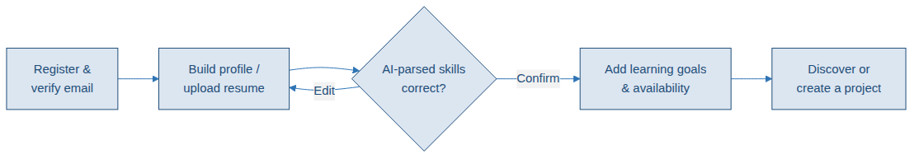
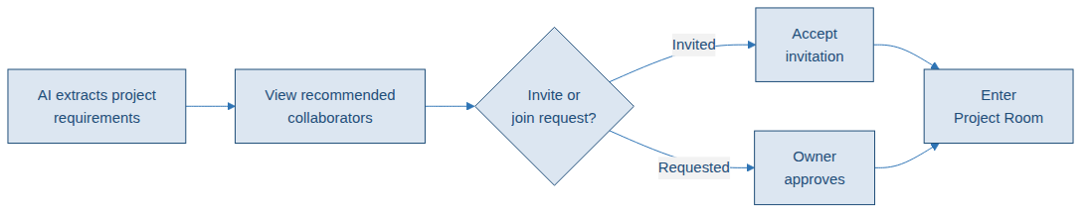
Figure 5.1 — Registration through to a portfolio update, spanning profile setup, discovery, team formation and verified experience.

5.2 Project Owner → Team Formation
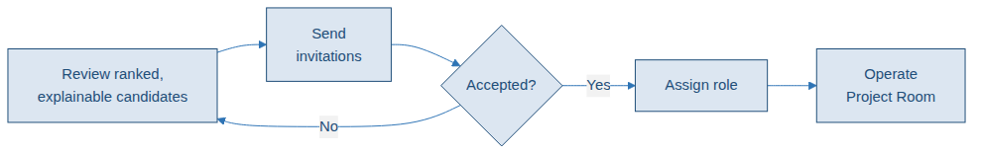
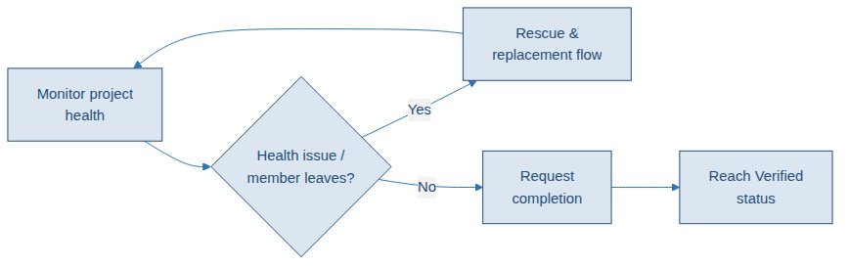
Figure 5.2 — From idea to a monitored, health-tracked project reaching Verified status, with rescue looping back into active operation.

5.3 Recruiter → Candidate
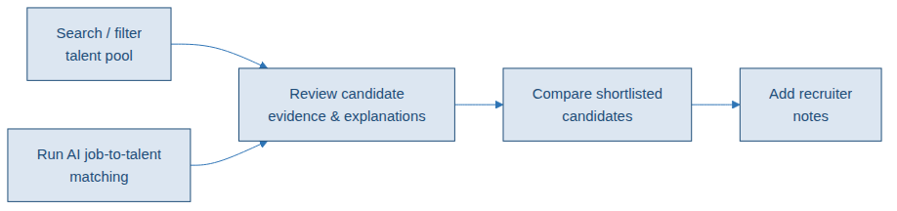
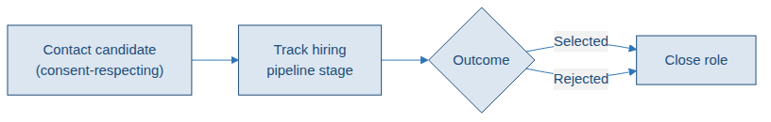
Figure 5.3 — Company setup through job posting, search/AI matching, shortlisting and the hiring pipeline.

5.4 Project → Verified Experience
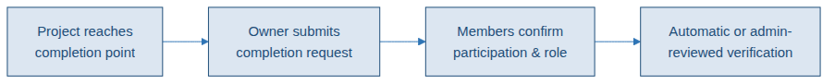
Figure 5.4 — Completion request through to a publicly verifiable certificate.

5.5 Rescue a Stalled Project
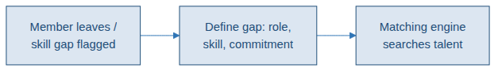
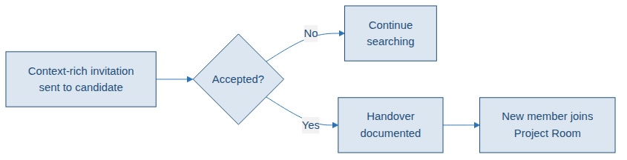
Figure 5.5 — Gap detection through matching, context-rich invitation, handover and re-entry into the Project Room.

6. Site Map / Screen Navigation
The full navigation surface, grouped by entry point (individual, recruiter, admin). This is the structural map engineering should use to plan routes/URLs and shared layout components.
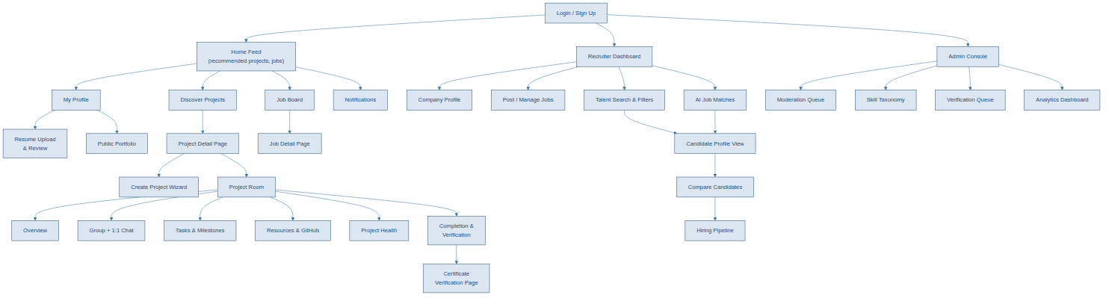
Figure 6.1 — Top-level navigation from login into individual, recruiter and admin surfaces.

7. How to Use This Document With the PRD
- Use the PRD for what each feature must do (fields, rules, edge cases, acceptance criteria).
- Use this document for how the system is structured (Section 2), how modules coordinate at runtime (Section 3), and what the resulting screens and flows look like (Sections 4–6).
- When implementing a feature, start from its PRD area number, cross-reference the relevant orchestration diagram if one exists (resume parsing, matching, or completion/verification), and use the matching wireframe as the layout reference.
- Treat the wireframes as structural references, not final visual design — typography, color system and spacing should follow the team's actual design system once one exists.

